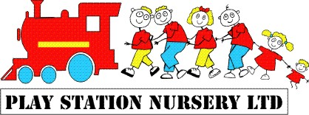

10. Equal Opportunities, valuing diversity and differences Policy

Children’s individual needs are met through positive observation, assessment and planning strategies. These strategies have been implemented as a result of our work with children with special educational needs and the use of individual play plans. At Play Station Nursery each child has a unique action plan that will serve to enhance their learning and development whatever their circumstances, abilities, race or religion, colour, gender, or first language, etc.
Each action plan will be reviewed on a monthly basis at which time each child’s key person will consider the observations that have been recorded, make considered assessments and decide how best to move each child forward.
Please note the Observation, Assessment and Planning Policies of Play Station Nursery.
Please note the Parents in Partnership Policy of Play Station Nursery.
Should our observations raise concern regarding a potential learning difficulty of any child these will be documented and shared with the parents/carers of the child. Parents/carers may choose to contact their own health visitor or doctor in the first instance.
If deemed necessary and with the parents agreement appropriate outside professionals will be contacted and requested to assist in the assessments and future planning of the child. The Special Educational Needs Co-ordinator for Play Station Nursery is Natalie Taylor

At Play Station Nursery we openly welcome all children and their families.
Diversity and differences are positively portrayed through the use of positive spoken language, books, images, play resources, dressing up clothes, etc. Children can be afraid of the differences they see in people; through the use of open discussion and positive affirmations it is possible to satisfy a child’s curiosity and fear.

Please note the behavior management policy of Play Station Nursery.
Please note the bullying policy of Play Station Nursery.

The Every Child Matters directive is a direct response to the need for all children to be looked after and cared for in a safe and happy environment.
At Play Station Nursery we will continue to work towards all children achieving the five outcomes through our group and individual planning.

Signature | Review date

