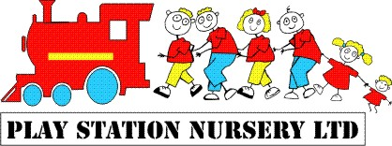

3. Child Protection Policy

In recognition of the important role we have to play in Safeguarding and Promoting Children’s Welfare, the staff at Play Station each undertake a strict induction process that is regularly assessed throughout their employment probation period. Assessments throughout each staff member’s employment, serves to ensure complete and continuing knowledge and understanding. Upon completing their probationary period staff are expected to be able to respond appropriately to:
- Significant changes in children’s behavior
- Deterioration in their general well-being
- Unexplained bruising, marks or signs of possible abuse
- Neglect
- The comments children make give cause for concern

All concerns will be documented in a factual and professional manner. In the event that a child is displaying any of the above symptoms, an explanation will be sought from the parents/carers.
Should a child enter nursery with an injury that has occurred outside of the setting a home injury form should be completed and a copy will be kept in the Child protection folder in the office.

In the event that an injury occurs whilst a child is in the care of nursery staff an accident, incident and/or head injury form will be completed and signed by the parent.
Any allegations of harm or abuse by a member of staff will be reported to your local LADO (Local Authority Designated Officer) – 01454 868508 (Tina Wilson) Access and Response Team (01454 866000), and (if appropriate) OFSTED, immediately and without delay. Neglecting to do this is an offence.
No discussions (between staff members or otherwise) will take place that may have a harmful impact on these investigations. Indeed, the staff member in question will be required to leave the premises pending formal and legal investigations. Please see our Safeguarding Children policy for more information.
The child protection nominated person is Natalie Taylor.

Signature | Review date

