38. Sleep time checking procedure and SIDS (Sudden Infant Death Syndrome)

Children who are based in the baby room and require a sleep may be placed in one of the cots in the cot room. Any child under the age of 2 years will be (without fail) visually checked on every ten minutes, breathing and sleeping positions will be monitored and staff will sign time and initials on the board located on the cot room door. Cot sheets are changed after each child.

A baby monitor is fitted so that babies can be volume monitored at all times when asleep.

Babies under 17 months will be put to bed in a sleeping bag, once they are asleep, comforters (excluding dummies) will be removed from the cots. Children over 17 months can go to bed with a blanket or sheet. If the room temperature is too warm, then all bedding including sleeping bags should be removed.

No child should be allowed to sleep in any of the bouncy chairs, or in buggies. There is an exception to buggy napping while on nursery trips.

Children over 20 months can sleep on mats or in the coracles in the playrooms, staff will supervise them until they are awake.
If at any time a child falls asleep outside of the normal sleep-time routine, they will be placed in a safe, comfortable area, in either the cot room or their playroom if this is safe and practical for them.

Parents are welcome to provide a comforter, ie. Dummy, blanket or teddy if this is likely to help their child settle. Those who require a bottle in the sleep room must have a member of staff supervise them until the bottle is empty or child falls asleep, dummy chains, bibs and loose clothing MUST be removed when putting children to bed.

Sleeping patterns will be agreed with parents/carers. There is no set time for sleeping whilst at nursery; we are happy to follow each child’s usual routine if possible. There are occasions where in the interest of the child we need to adjust their routine, this may be due to illness, or a bad a night’s sleep. While we appreciate that children’s daytime routines can impact their night-time routine our priority has to be the emotional welfare of the child in that moment, for this reason, on occasion it may be necessary for us to alter routines.

Allowing children, the time they need to rest and recharge has to be our priority. For them to be happy, eat well and thrive they need an appropriate amount of sleep that suits their bodies. Some children may sleep a lot less than others; this is their natural sleeping pattern. We are happy to support families by reducing certain sleep times to aid better night’s sleep, but we will not wake a sleeping baby for anything less than 45 minutes, unless we feel it is in the direct and immediate benefit of the child. Children over 2 can be woken after 30 minutes if this is in the direct and immediate interest of the child.

In the even that a family choose for their child not to sleep while at the setting we will aim to follow this but we are not able to force children to stay awake and if it felt that the child or baby is in need of a sleep this will be allowed for the minimum amount of time.

If the baby is unwell, seek medical help promptly.
Babies often have minor illnesses these can sometimes turn into temperatures and result in febrile convulsions. If a child is unwell, they should be checked on more frequently and their temperatures checked regularly. If they develop a temperature while sleeping the child should be woken to ensure they are responsive, a parent or carer contacted to collect or administer Calpol, if appropriate. The child should not be left unattended if they fall back to sleep, a staff member should stay with them and continue to monitor their temperature until they are collected.

It can be difficult to judge whether an illness is more serious and needs urgent medical attention. See spotting the signs of serious illness for guidance on when to get help.

Signature | Review date

Reducing the risk of sudden infant death syndrome (SIDS or ‘cot death’)
It's not known why some babies die suddenly and for no apparent reason from sudden infant death syndrome (SIDS) or cot death.
Experts do know placing a baby to sleep on their back reduces the risk, and exposing a baby to cigarette smoke or allowing them to overheat increases the risk. It's also known there's an association between sleeping with babies on a bed, sofa or chair (co-sleeping) and SIDS.

How to reduce the risk of SIDS
- Don't let the baby get too hot or cold.
- Keep the baby's head uncovered. Their blanket should be tucked in no higher than their shoulders.
- Place the baby in the "feet to foot" position, with their feet at the end of the cot or Moses basket.

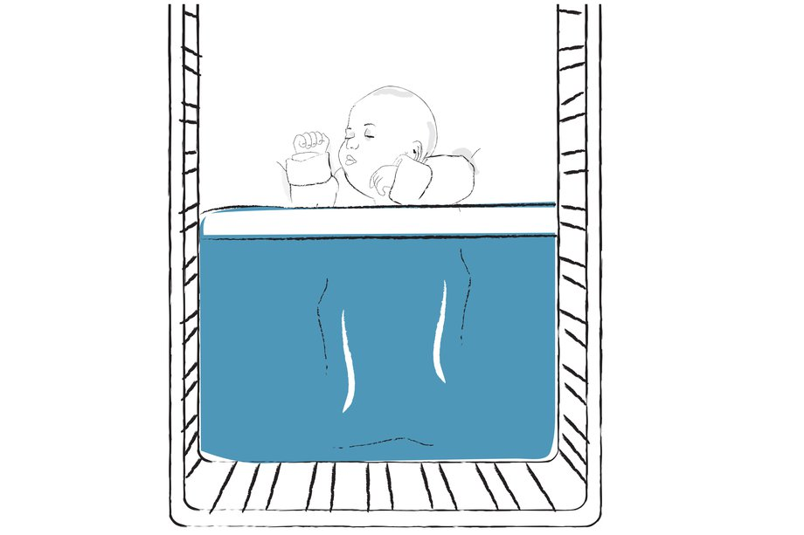
Place the baby on their back to sleep

Place the baby on their back to sleep from the very beginning for both day and night sleeps. This will reduce the risk of cot death.
It's not as safe for babies to sleep on their side or tummy as on their back. Healthy babies placed on their backs are not more likely to choke.
Once the baby is old enough to roll over, there's no need to worry if they turn onto their tummy or side while sleeping.

Don't let the baby get too hot or too cold
Overheating can increase the risk of SIDS. Babies can overheat because of too much bedding or clothing, or because the room's too hot.
- When you check the baby, make sure they're not too hot. If the baby is sweating or their tummy feels hot to the touch, take off some of the bedding. Don't worry if their hands or feet feel cool – this is normal.
- It's easier to adjust for the temperature by using layers of lightweight blankets. Remember, a folded blanket counts as 2 blankets. Lightweight, well-fitting baby sleeping bags are a good choice, too.
- Babies don't need hot rooms. All-night heating is rarely necessary. Keep the room at a temperature that's comfortable for you at night – about 18C (65F) is ideal.
- If it's very warm, the baby may not need any bedclothes other than a sheet.
- Even in winter, most babies who are unwell or feverish don't need extra clothes.
- Babies should never sleep with a hot water bottle or electric blanket, next to a radiator, heater or fire, or in direct sunshine.
- Babies lose excess heat through their heads, so make sure their heads can't be covered by bedclothes while they're asleep.
- Remove hats and extra clothing as soon as you come indoors or enter a warm car, bus or train, even if it means waking the baby.
- Do not put a child to bed with a rising temperature. If they are unwell and fall asleep they should remain with a practitioner until the parent/carer arrives.

Don't let the baby's head become covered
Babies whose heads are covered with bedding are at an increased risk of SIDS. To prevent the baby wriggling down under the covers, place them in the "feet to foot" position. This means their feet are at the end of the crib, cot or Moses basket. Uncover babies who cover their own heads with blankets or muslin cloths.

How to put the baby in the 'feet to foot' position
- Tuck the covers in securely under the baby's arms so they can't slip over their head. Use one or more layers of lightweight blankets.
- Use a baby mattress that's firm, flat, well-fitting and clean, and waterproof on the outside. Cover the mattress with a single sheet.
- Don't use duvets, quilts, baby nests, wedges, bedding rolls or pillows.

